Task 1 output:

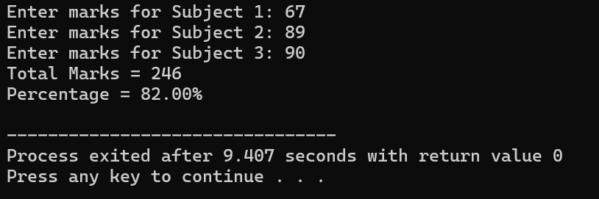

Task 2 output:

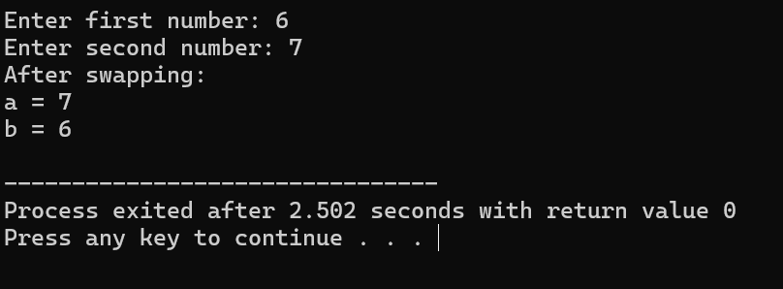

Task 3 output:

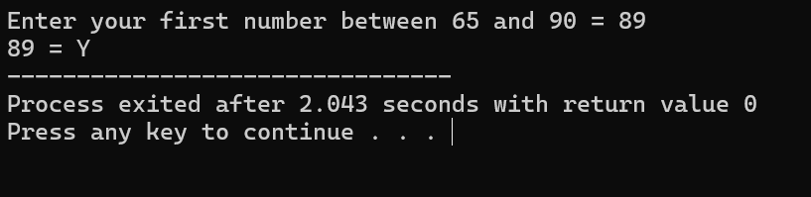

Task 4:

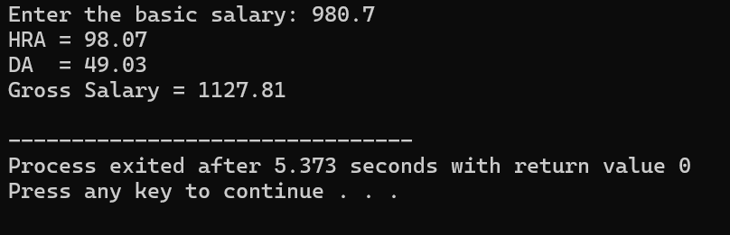

Task 5:

